**Model and Diagnostic Testing**

AR(1)

H0: Residuals resembles white noise.

H1: Model suffers from autocorrelation in the residuals.

Since the probability is more than 0.05 for all lag, we fail to reject null hypothesis. Therefore, the model does not suffer from autocorrelation. As such, the model AR(1) is adequate to use for forecasting purposes.

**Forecasting (In-Sample)**

**Comparing Actual vs Forecasted Values (In-Sample)**

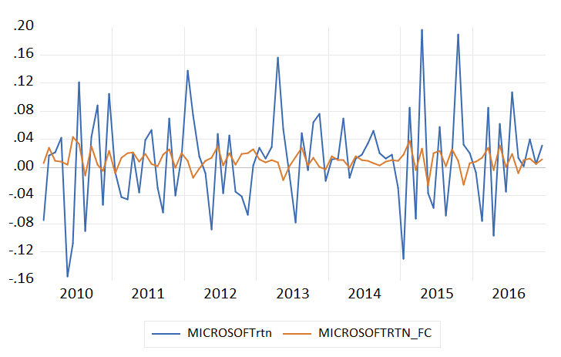

The forecasted series follows the general trend and pattern (up and down alignment) of the actual series. However, the forecasted returns are smoother and fail to capture some extreme fluctuation in the actual data as it shows periods of higher volatility. Since the deviation is large, it suggests that AR(1) model may struggle to forecast extreme movements or shocks. Overall, the model appears to perform reasonably well but it may need adjustments to better handle volatility.

**Evaluating Forecast Accuracy (In-Sample)**

Root Mean Squared Error (RMSE): 0.064932

Mean Absolute Error (MAE): 0.048498

Mean Absolute Percentage Error (MAPE): 98.3326%

SMAPE: 136.2798%

Theil U1: 0.772493

Theil U2: 0.947286

Since the RMSE and MAE values are relatively low, this indicates that the absolute errors are not in large scale. However, the high MAPE and SMAPE values suggest that model struggles to predict extreme return, as percentage-based errors are significantly high. This could be due to high volatility periods in the data, which the model may not be capturing effectively. The Theil U2 is below 1 (though better than a naïve random walk), it shows only limited improvement. The model may need refinement to improve its forecasting performance.

**Forecasting (Out-of-Sample)**

**Comparing Actual vs Forecasted Values (Out-of-Sample)**

The overlap between the two series before 2017 indicates that the model fits the training data well with high accuracy. However, when out-of-sample forecasting occurs (Q1 2017), a noticeable divergence occurs. This can be seen especially clear during periods of high volatility (Q3 and Q4). The forecasted series is much smoother compared to the actual data with high spikes. The model is said to underestimate the magnitude of extreme shock. Overall, the model may be overfit to the training sample as it shows significant deterioration in performance when applied to unseen data. The model also is overly simplistic as it fails to capture sudden market movement (high peak and trough) which indicates the lack of adaptability to external shocks.

**Evaluating Forecast Accuracy (Out-of-Sample)**

Root Mean Squared Error (RMSE): 0.037409

Mean Absolute Error (MAE): 0.028315

Mean Absolute Percentage Error (MAPE): 114.3737 %

SMAPE: 145.6251%

Theil U1: 0.703683

Theil U2: 0.843762

**Comparison between In-Sample and Out-of-Sample Model**

The out-of-sample model slightly performs better in terms of RMSE, MAE and Theil U statistics. This suggests that it has generalizability and avoids overfitting to the training data. However, the percentage-based error metrics such as MAPE and SMAPE is higher than the in-sample data. Both models struggle to forecast extreme volatility periods accurately (although in-sample is better out of the two in this regard).